Media Guide Shout Outs
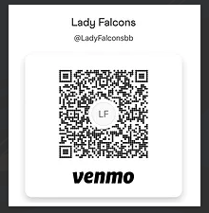
The Falcon Booster Club is selling “shout outs” for the girls and boys basketball players/coaches/managers, cheer, dance, pep band & Falcon Flight Crew. These are short words of encouragement or praise from the parents, grandparents, family, friends, or others that will be included in our 2022-2023 basketball program. Each shout out is $5.00 each and generally range from 10 to 75 words.

Email shout out text to ladyfalconsboosterclub@gmail.com by November 30th and Venmo $5 by scanning the QR code above. You may also print this form and give to your coach in an envelope with money. Label the envelope & payment to Lady Falcons Booster Club.

Name(s) of those sending the Shout-Out:____________ _____________________________________________
Email Address:_________________________________
Player Name:__________________________________
Shout-Out: ____________________________________ _____________________________________________
_____________________________________________
____________________________________________________________________________________________________________________________________________________________________________________

