The Falcon Booster Club is selling “shout outs” for the girls and boys basketball players, managers, and/or coaches. These are short words of encouragement or support to be included in our 2023-2024 basketball media guide. Each shout out is $5.00 and generally ranges from 10 to 75 words.
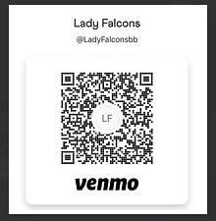
To submit, you may choose one of these options:
- Email your shout out text to osladyfalconsbb@outlook.com by November 30th and Venmo $5 by scanning the QR code above.
- Print & give a completed form to your coach in an envelope with exact amount required addressed to Lady Falcons Booster Club.
- Print & mail completed form with exact amount required to 15324 South Foxridge St, Olathe, KS 66062.

Email osladyfalconsbb@outlook.com with any questions.
Thank you!

Name(s) of those sending Shout Out:
Email Address (in case we need to contact you):
Recipient’s Name:
Shout Out Message

